SHIMICOAT Abrasion Resistant Repair Magmapoxy – Reinforced High Build Epoxy
High-Strength, Structural, Rapid Curing Epoxy, Smooth Roller/Brush/Trowel Adhesive
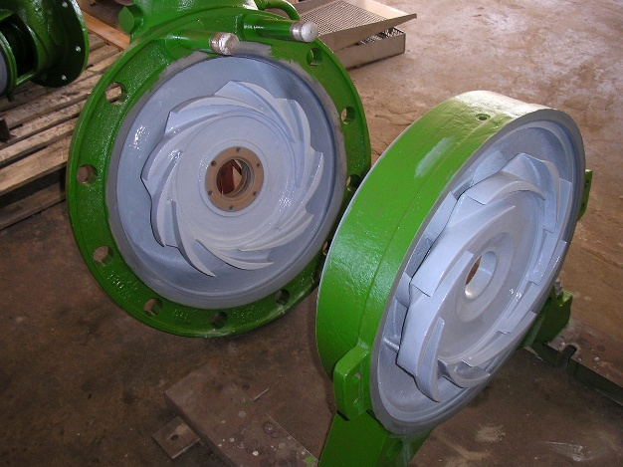
Abrasion Resistant Repair Magmapoxy
SHIMICOAT Abrasion Resistant Repair Magmapoxy is an advanced composite three-part ceramic epoxy system designed to leverage the benefits of epoxy polymer technology while incorporating corrosion inhibitor properties. Unlike traditional materials, it does not ware off and does not deteriorate, making it ideal for applications exposed to extreme erosion and highly corrosive conditions. It offers superior ware resistance, excellent adhesion, and high mechanical strength.

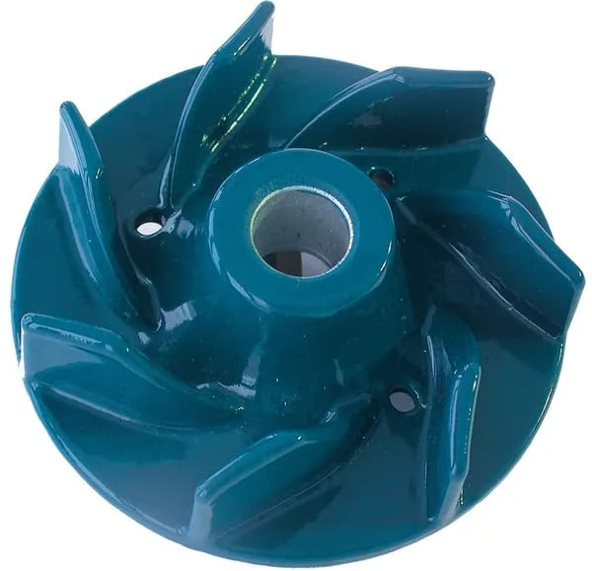
This three-component ceramic epoxy composite contains graded inorganic fillers known for their exceptional hardness and abrasion resistance. The ceramic component of coating is engineered spherical super ceramic materials that are hard, durable, seamless and easy to apply. Once cured, the polymer binder forms a tough, infusible material with strong chemical resistance, bonding securely to well-prepared surfaces such as metal, wood and concrete.
Abrasion Resistant Repair Magmapoxy is ideal for treating new or damaged surfaces and components, extending their lifespan under extreme abrasive and erosive conditions, such as exposure to constant water or even chemical flows. While it can be applied as a thin film, a minimum thickness of 2mm is recommended, by multi-applications. In most cases, thicker applications enhance durability. It can also be applied to inverted surfaces without sagging or falling when combined with a fine-grade aggregate such as Carbosil or Silica Fume.

Key Benefits

- Water Approved AS/NZS 4020:2018
- HACCP INTERNATIONAL Approved
- FOOD SAFE
- Three pack Ceramic Coating system
- Easy to apply (brush, roller and trowel)
- Non-flammable / Zero VOC
- No burning, smoking, or fuming under molten metal exposure
- High Abrasion Resistance
- Varying Application Thickness
(300micron to over 40mm in one coat)
- High Mechanical & Impact Strength
- Outstanding Corrosion Inhibitor
- Excellent Chemical Resistance
- Fast Curing & Reduced Downtime (24Hrs)
- Refractory Properties
- Resists Burns, Smoke and Fume
- No Shrinkage
- Excellent Substrate Adhesion
- Superior Intercoat Adhesion
- Easy to Mix & Apply
- Can be applied to horizontal, vertical, and inverted surfaces
- Temperature Stability -40°C to150°C
- Versatile Application

INDUSTRY APPLICATIONS

- Industrial Pumps
- Pump Lines and Accessories
- Treatment plants
- Waste treatment operations
- Metal refineries
- Foundries
- Smelters
- Heat containment facilities
- Oil Rigs
- Tank Lining
- Metal / Concrete Surface Coating
- Structural Repair & Resurfacing
- Grouting & Bonding
- Abrasion & Impact Protection
- Chemical & Heat Resistance Coating
- Molten Metal Spillage Protection
- Metal Refineries
- Foundries
- Power Generation
- Heat Containment
- Minerals Processing Plants
- Chemical floors
- Chemical bunds
- Mining industry
- Containment bunds
- Mineral processing floors
- Extreme and high traffic floors
- Factories and warehouses

SPECIFICATIONS

Mixing ratio by Weight (Kg) or Volume (Lt)  Part C can be added at any ratio of 5% to 20% | 4A:1B  5% Smooth Slurry / 20% Ceramic Epoxy Mortar
Colour of Blend | Crystal Clear and transparent
Pot Life @25°C | 30min
Re-Coating Time @25°C | 16 Hours
Application Ttemperature (min 3°C above Dew Point) | 5 to +30 °C
Overcoating @ 25 °C | 12 -24 hours
Cure time @ 25 °C | 12 - 20 hours
Coefficient of expansion – Aggregated for Grouting  Slightly More than concrete | 12-14 x 10⁻⁶ / °C
Coefficient of expansion - Concrete | 8-12 x 10⁻⁶ / °C
Adhesive strength | > 1.5 MPa
Compressive Strength: | 13,000 psi (89.6 MPa) – ASTM D695
Flexural Strength: | 5,500 psi (37.9 MPa) – ASTM D790.
Adhesion to Steel: | 2,700 psi (18.62 MPa) – ASTM D1002
Abrasion Resistance: | 820 mm³ per 1,000 cycles – ASTM D4060  14 mm³ per 1,000 cycles – ASTM D4060.
Heat Distortion Temperature: | 97°F (36°C) – ASTM D648.
Thermal Conductivity: | 1.9 W/mK – BS 874.
Coefficient of Thermal Expansion: | 28.2 ppm/°C – ASTM E228.
Dielectric Strength: | 142.5 volts/mil (5700 volts/mm) – ASTM D149.
Volume Resistivity: | 1.0 × 10¹³ ohm·cm – ASTM D257.
Tensile strength | 7 MPa
Elastic Modulus | 2 GPa
Compressive strength | 45 - 55 MPa
Temperature resistance | -20 °C to >250 °C
Hardness (Shore D) | 80 (7 days)

CHEMICAL RESISTANCE
1014ER exhibits excellent resistance to Acids, Alkalis and Solvents
Media | Reagent |  |  | Rating
Acids | Hydrochloric Acid |  |  | A
Acids | Sulphuric Acid |  |  | B
Acids | Acetic Acid |  |  | A
Acids | Nitric Acid (20% max) |  |  | B
Acids | Phosphoric Acid (25% max) |  |  | A
Alkalis | Sodium Hydroxide |  |  | A
Alkalis | Ammonium Hydroxide |  |  | A
Alkalis | Potassium Hydroxide |  |  | A
Alkalis | Sodium Hypochlorite (Bleach) |  |  | A
Solvents | Xylene |  |  | A
Solvents | Methyl Ethyl Ketone (MEK) |  |  | B
Solvents | Diesel |  |  | A
Solvents | Ethanol |  |  | A
Solvents | Acetone |  |  | A
Solvents | Kerosene |  |  | A
Solvents | Petrol |  |  | A
Solvents | Wine & Beer |  |  | A
Code |  | Resistance | Description
A |  | Excellent | Suitable for Long term immersion
B |  | Good | Suitable for Short-term immersion (Max 3 days)
C |  | Caution | Very short contact time is OK, spill and splash
D |  | Danger | Not Recommended
Indicative reference only. Tested in laboratory conditions at 25°C.

Resistance properties of HT 1000

THERMAL PROPERTIES | Thermal Conductivity: 1.9 W/M°K / BS 874 / Thermal Expansion Coefficient: 28.2 ppm/°C / ASTM E228 / Thermal Stability: 140°C | Alkalis | Resist Short term immersion in all alkalis.
Weather Proofing | All Epoxy Coatings may yellow with time. Weatherproof top coat may be used if required. | Salts & Brines | Resist continuous or long-term immersion in all Salts & Brine systems.
Solvents | Resistant to most hydrocarbon solvents and alcohols. | Water | Excellent resist to continuous or long term immersion in fresh & Salt Water.
Acids | Resist splash and spills in all acids. | Abrasion | Excellent when fully cured (7 Days)

Surface Preparations
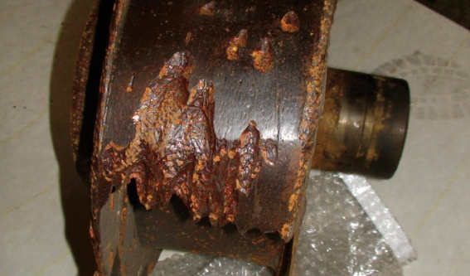
To ensure proper adhesion, the substrate MUST be clean and free from loose particles.
Suitable preparation methods include:
- Abrasive blasting
- Mechanical/Chemical Etching
- Grinding
- Scarifying
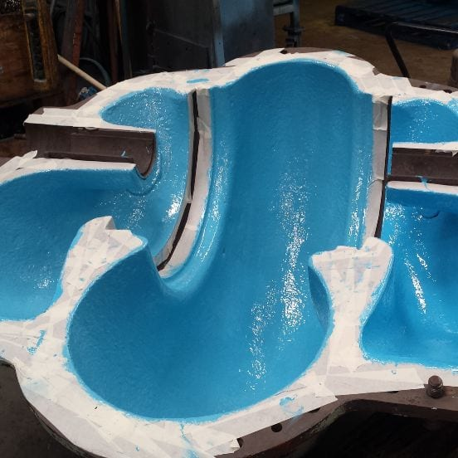
Clean and dry surface. Ensure surface to be coated is free of all dirt, grease, oil, paint, curing agents and other contaminants. Removal of Oil Contamination by degreaser and alkaline cleaning pressure wash
Acid-wash to enhanced surface porosity and etch the surface. Ensure moisture free surface. Allow to completely dry, run Dry Test. Place a piece of plastic over a small area, tape the edges and leave for 1 hour. Remove plastic, if there is no moisture on either surface, concrete is sufficiently dry. Ideally, always consider sanding, surface grinding and removal of loose materials. Mechanical sanding or grinding is always advisable prior to application of all Shimicoat Epoxy products, to maximize adhesion.

For further information, please refer to SHIMICOAT Instruction for “Surface Preparations”.

Mixing Instructions
- Mix Component A with Component B using a slow-speed mixer or spatula until homogeneous.
- Retain a small amount of mixed resin for priming the substrate and final touchup / topcoat.
Add selected ceramic (QCell) to the remaining mix and blend until uniform.
Application Methods
- Apply using gloved hands, scrapers, putty knives, or flat steel trowels.
- Can be applied on horizontal, vertical, and inverted surfaces without sagging.
- Using brush or roller apply epoxy blend over the final surface to a smooth finish surface
MORTAR PREPARATION
1014ER acts as a binder for aggregate materials. Recommended aggregate
- Silica Sand (600µ or less)
- Sintered Aluminium Oxide
- QCell or Super Ceramic
- Carbosil or Silica Fume
Mix Ratios
Add aggregate/filler materials at your desired consistency.

Putty Consistency – Guideline
Consistency | Fix Quantities  CANNOT be changed |  | Adjust As Required | Application
Consistency | Part A | Part B | Part C | Application
Thin Slurry  Syrup | 4 Parts / 80gr | 1 Part / 20gr | 20% / 20gr | Hairline Repairs
Thick Slurry  Honey | 4 Parts / 80gr | 1 Part / 20gr | 50% / 50gr | Small Cracks
Thick Slurry  Tomato Sauce | 4 Parts / 80gr | 1 Part / 20gr | 75% / 75gr | Large Surface Fill
Thick Slurry  Mayonnaise | 4 Parts / 80gr | 1 Part / 20gr | 100% / 100gr | Fill & Repair  Larger Cracks
Thick Slurry  Mash Potato | 4 Parts / 80gr | 1 Part / 20gr | 150% / 150gr | Fill & Repair  Larger Cracks
Thick Slurry  Peanut Butter | 4 Parts / 80gr | 1 Part / 20gr | 200% / 200gr | Fill & Repair  Larger Cracks

Curing Times
SHIMICOAT Abrasion Resistant Repair Magmapoxy dries in 8-20 hours depending on atmospheric temperature. High temperatures and windy conditions may speed up the curing time. Complete curing process and full hardness is achieved after 7 days.

Temp °C | Pot Life (min) | Surface Dry (Hours) | Initial Cure (Hours) | Recoat Time (Hours) | Fully Cured (Days)
10°C | 45 | 12 | 24 | 24 | 7 Days
20°C | 40 | 10 | 18 | 18 | 7 Days
30°C | 35 | 8 | 16 | 16 | 7 Days
WARNING
The curing agent (Part B – Hardener) of Abrasion Resistant Repair Magmapoxy has a freezing point of 15°C, and similar to honey, paraffin and wax it may solidify at lower temperatures during cold seasons. Simply:
  - Warmup the container to 60°C,
  - Mix for 3-4min to uniform,
  - Let it cool down to room temperature (25°C)
  - Use as normal.
Direct sunlight and UV radiation my result in chalking, colour variations and yellowing effect over time. UV stable topcoat application shall be used. Please consider SHIMICOAT PolyAspartic for longevity and better performance.

Storage
The products shall be stored out of direct sunlight and heat at all times (0°C to 30°C).
The shelf life of the product is 5 years, mix uniformly for 3 minutes prior to use.

DISCLAIMER
Material Safety Data Sheet, Technical and Environmental Data Sheet can be provided upon request.
The information provided in this document is guidance only and considering the uses of this product are beyond the seller's control, the product is sold without guarantees or warranties. Warranties and guarantees shall be governed by SHIMICOAT Standard Terms of Sale. The purchaser shall make its own tests to determine the suitability for their specific application, and Shimicoat Pty Ltd is taking no responsibility for misuse of the product. The purchaser assumes all risk of use and handling of this product. This product will be happily replaced or credited back if defective. Beyond this, Shimicoat Pty Ltd is not liable for any damages caused by this product or its use.
This information and all further technical advice are based on our present knowledge and experience.
The customer is not released from the obligation to conduct careful inspection and testing of supplied goods.

