SHIMICOAT Crack Seal Magmapoxy – Epoxy Mortar Repair Kit
High-Strength, Structural, Rapid Curing Epoxy, Smooth-Paste Adhesive
Product Overview:
SHIMICOAT Crack Seal Magmapoxy is a high-performance, moisture tolerant, structural epoxy mortar designed for fast and reliable patching and surface repair. It combines Ultra Clear Epoxy Resin (100% Solids) with advanced Super Ceramic Filler materials to create a paste with customizable consistency—ideal for repairing concrete, metal, timber, and plastic surfaces.
Key Benefits:
- High Strength Finish: Achieves a surface strength exceeding 50 MPa, stronger than standard concrete.
- Super Ceramic Reinforcement:
  - Enhances rheology (flowability for easy application)
  - Minimizes sag and shrinkage
  - Increases impact resistance
  - Chemically inert and non-absorbent
  - Can be used on damp concrete
  - Excellent adhesion to the substrate
Applications:
- Structural surface rebuild and crack repair
- Pre-treatment before protective or decorative coatings
- Suitable for large-scale surface preparation and restoration projects
Advantages:
- 100% Solid Epoxy: No VOCs, no shrinkage
- Easy to mix and easy to apply with minimal tools
- Offered in three convenient kit sizes: Small, Medium, and Large
- Delivers a modern, hygienic, functional, and economical finish
Ideal For:
- Installers and applicators needing rapid, high-strength surface repairs
- Projects requiring a durable epoxy mortar with superior performance and workability
Available in Small, Medium, and large kits to suit different repair volumes.
Small
Product Description | Size | Code | Quantity
Super Ceramic Filler Materials | 5Lt | SC | 1
Ultra-Clear Epoxy 100% Solid | 1.5Lt | UC | 1

Medium
Product Description | Size | Code | Quantity
Super Ceramic Filler Materials | 10Lt | SC | 1
Ultra-Clear Epoxy 100% Solid | 3Lt | UC | 1

Large
Product Description | Size | Code | Quantity
Super Ceramic Filler Materials | 20Lt | SC | 1
Ultra-Clear Epoxy 100% Solid | 6Lt | UC | 1

Each Kit Includes
Commercial Grade Crack Seal Magmapoxy contains:
- Order size Super Ceramic Filler Materials
- Order size Ultra Clear Epoxy 100% Solid
Kit Size | Super Ceramic  Filler Materials | Ultra Clear Epoxy 100% Solid  Kit Size (Lt)
Small (6.5Lt) | 5Lt | 1.5Lt
Medium (13Lt)) | 10Lt | 3L
Large (26Lt) | 20Lt | 6L

Kit Size | Kit Contains
Small Kit | 5Lt (2Kg) Super Ceramic Filler Materials with 1.5Lt of Ultra Clear Epoxy 100% Solid.
Medium Kit | 10Lt (4Kg) Super Ceramic Filler Materials with 3Lt of Ultra Clear Epoxy 100% Solid.
Large Kit | 20Lt (8Kg) Super Ceramic Filler Materials with 6Lt of Ultra Clear Epoxy 100% Solid.

Usage
Super Ceramic shall be added to Premixed (Part A and Part B) Ultra Clear Epoxy, twice as much as resin quantity (200% by volume). Extra Super Ceramic can be added for special applications.

Applications
Use Trowel, Scraper or Spatula to smear over the cracked surface and fill the gap. Remove excessive and wipe off using scraper. Pour over the surface and squeegee to spread out and level.

Dry Time at 25°C

Pot Life: | 45 minutes at 25°C
Tack Free: | 2-3 hours
Thin Film Set: | 8 Hours (Min, depending on temperature and humidity)
Deep Cast Set: | 24 Hours (Min, depending on temperature and humidity)
Dry Cured: | 12-16 hours – Foot Traffic (depending on temperature and humidity)
Fully Cured: | 7 days (Vehicle Traffic)
Re-Coat: | Over night

Clean Up
EpoThin - Thinner & Diluent (Blend of Solvents).

Preparations
Clean and dry surface. Ensure surface to be coated is free of all dirt, grease, oil, paint, curing agents and other contaminants. Removal of Oil Contamination by degreaser and alkaline cleaning pressure wash
Acid-wash to enhanced surface porosity and etch the surface. Ensure moisture free surface. Allow to completely dry, run Dry Test. Place a piece of plastic over a small area, tape the edges and leave for 1 hour. Remove plastic, if there is no moisture on either surface, concrete is sufficiently dry. Ideally, always consider surface grinding and removal of loose materials. Grinding is always advisable prior to application of all Shimicoat Epoxy products, to maximize adhesion. For further information, please refer to SHIMICOAT Instruction for “Surface Preparations”.

Features
SHIMICOAT Crack Seal Magmapoxy Kit – High-Performance Epoxy Mortar System
The Crack Seal Magmapoxy Kit is a premium-grade repair solution engineered for civil construction applications. It comprises 100% solid clear epoxy resin reinforced with Super Ceramic Filler materials, delivering unmatched durability and surface hardness. This kit is specifically designed for installers and contractors seeking a fast, strong, and long-lasting repair system prior to protective coating application.
Key Features:
- Advanced Super Ceramic Filler Technology
Delivers exceptional reinforcement and surface integrity.
- Superior Epoxy Structure – Ensures maximum bonding and mechanical strength.
- User-Friendly Formulation – Lightweight, easy to mix, and simple to apply.
- High Compressive Strength – Withstands significant structural loads.
- Thermal Stability – Maintains performance across a wide temperature range.
- Longevity – Engineered for service life exceeding 20 years.
- Ideal Rheology – Suitable for both horizontal and vertical applications without sagging.
- Enhanced Fire Resistance – Improved fire rating for safety-critical environments.
- Modern and Hygienic Finish
Functional and economical solution for civil, commercial, and industrial use.
- Chemical and Traffic Resistance
Withstands harsh chemicals, heavy pedestrian use, and vehicular traffic.
- DIY Friendly – Easy to use for both professionals and trained individuals.
Available in Small, Medium, and Large kits, SHIMICOAT Crack Seal Magmapoxy is your go-to solution for surface restoration, crack repair, and substrate preparation in demanding environments.

Specifications
Physical & Chemical properties of Crack Seal Magmapoxy:
Pot Life @25°C | 45min
Colour of Blend | Resin is Ultra Clear and transparent  Blended with Super Ceramic is Light Grey (Super Ceramic Colour)
Consistency and Flow | Addition of Super Ceramic improves consistency “Easy to apply paste”
Touch Dry | 4 Hours
Initial Cure Time | 8-20hours (depending on temperature)
Ultimate Cure Time (Days) | 7 Days
MPa of Epoxy Mortar | >50
Maximum Temperature Exposure (°C) | 140

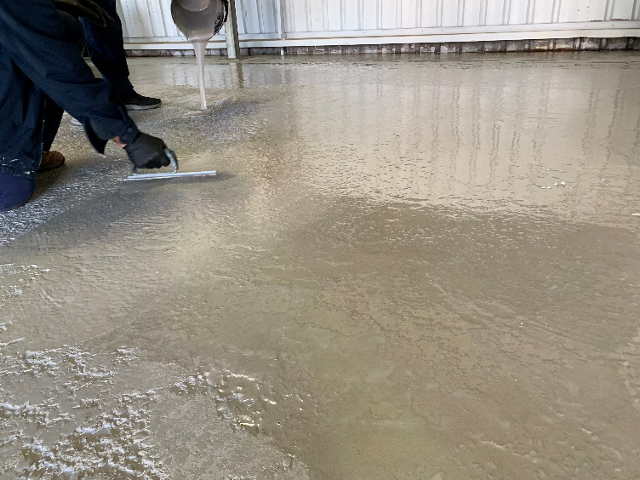
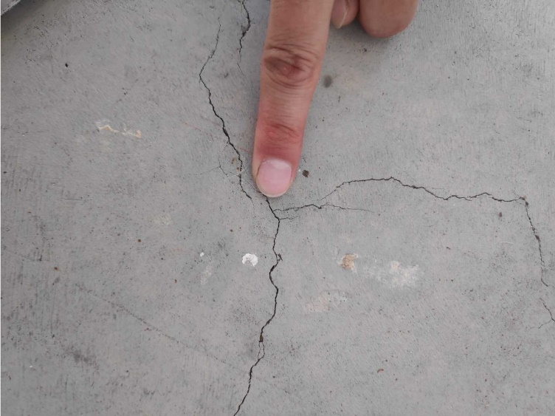

Specific resistance properties of Crack Seal
Media |  | Reagent |  | Rating
Acids |  | Hydrochloric Acid |  | B
 |  | Sulphuric Acid |  | C
 |  | Acetic Acid |  | B
 |  | Nitric Acid (10% max) |  | C
 |  | Phosphoric Acid (25% max) |  | B
Alkalis |  | Sodium Hydroxide |  | B
 |  | Ammonium Hydroxide |  | A
 |  | Potassium Hydroxide |  | B
 |  | Sodium Hypochlorite (Bleach) |  | A
Solvents |  | Xylene |  | A
 |  | Methyl Ethyl Ketone (MEK) |  | C
 |  | Diesel |  | A
 |  | Ethanol |  | A
 |  | Acetone |  | B
 |  | Kerosene |  | A
 |  | Petrol |  | A
 |  | Wine & Beer |  | A
Code | Resistance |  | Description
A | Excellent |  | Suitable for Long term immersion
B | Good |  | Suitable for Short-term immersion (Max 3 days)
C | Caution |  | Very short contact time is OK, spill and splash
D | Danger |  | Not Recommended
Indicative reference only. Tested in laboratory conditions at 25°C.

Resistance properties of Crack Seal Magmapoxy
Heat Resistant | 140°C | Alkalis | Resist Short term immersion in all alkalis.
Weather Proofing | All Epoxy Coatings may yellow with time. Weatherproof top coat may be used if required. | Salts & Brines | Resist continuous or long-term immersion in all Salts & Brine systems.
Solvents | Resistant to most hydrocarbon solvents and alcohols. | Water | Excellent resist to continuous or long term immersion in fresh & Salt Water.
Acids | Resist splash and spills in all acids. | Abrasion | Excellent when fully cured (7 Days)
Direction
Mix Twice as much as resin quantity used (200% by volume)
For example, if using Ultra Clear Epoxy, add 1.0Lt of Part B (Curing Agent) into 2.0Lt of Part A (Resin), mix for 2-3minutes and add 6.0Lt (2.4Kg) of Super Ceramic Filler. If necessary, add EpoSeal Diluent at a rate of up to 5% to smoothen the paste.

Mixing:
Mix thoroughly for a minimum 3 minutes manual or with mechanical mixer at low speed (750rmp Max) to ensure uniformity of the product.

Consistency | Fix Quantities  CANNOT be changed |  | Adjust As Required | Application
Consistency | Part A | Part B | Part C | REPAIR Mode | Mobility of Putty
Thin Slurry  Syrup | 4 Parts / 80gr | 1 Part / 20gr | 20% / 20gr | Hairline Repairs | Highly Mobile
Thick Slurry  Honey | 4 Parts / 80gr | 1 Part / 20gr | 50% / 50gr | Small Cracks
Thick Slurry  Tomato Sauce | 4 Parts / 80gr | 1 Part / 20gr | 75% / 75gr | Large Surface Fill
Thick Slurry  Mayonnaise | 4 Parts / 80gr | 1 Part / 20gr | 100% / 100gr | Fill & Repair  Larger Cracks
Thick Slurry  Mash Potato | 4 Parts / 80gr | 1 Part / 20gr | 150% / 150gr | Fill & Repair  Larger Cracks
Thick Slurry  Peanut Butter | 4 Parts / 80gr | 1 Part / 20gr | 200% / 200gr | Leak STOP | Zero Mobility
Putty Consistency – Guideline

Helpful Hints:

- Ensure surface to be coated is dry. Moisture can cause blooming and delamination.
- Pot life is approximately 45 minutes, work within 30min to ensure ideal rheological properties and easy flow application.
- Use steady long strokes and avoid overworking the roller or pushing your roller too quickly as this may trap air bubbles in the coating.
- Do not apply, if the rain is expected within 24 hours of application.
- Not recommended for use below 10°C or above 35°C.
- New concrete should be allowed to cure fully (at least 20days) before application.
- Keep the containers (Pail or Cans) sealed when not in use.
- Avoid application on hot surface.

Drying Times
SHIMICOAT Crack Seal Magmapoxy dries in 8-20 hours. High temperatures and windy conditions may speed up the curing time.
Keep foot traffic off for, at least 16 hours and vehicles for at least 7 days. Full hardness is achieved after 7 days.

Temp °C | Pot Life (min) | Surface Dry (Hours) | Initial Cure (Hours) | Recoat Time (Hours) | Fully Cured (Days)
10°C | 45 | 12 | 24 | 24 | 7 Days
20°C | 40 | 10 | 18 | 18 | 7 Days
30°C | 35 | 8 | 16 | 16 | 7 Days
WARNING
- Heavy vehicles with hot tires may cause damage on driveway. Avoid driving over the newly repaired floors till completely cured (7 Days).
- Do not apply Crack Seal Magmapoxy, if the concrete has a patchy appearance as moisture may be present. Dry Test prior to application, commence application when fully dry and moisture free.
Storage
The products shall be stored out of direct sunlight and heat at all times. The shelf life of the product is 24 months, mix uniformly for 3 minutes prior to use.
DISCLAIMER
Material Safety Data Sheet, Technical and Environmental Data Sheet can be provided upon request.
The information provided in this document is guidance only and considering the uses of this product are beyond the seller's control, the product is sold without guarantees or warranties. Warranties and guarantees shall be governed by SHIMICOAT Standard Terms of Sale. The purchaser shall make its own tests to determine the suitability for their specific application, and Shimicoat Pty Ltd is taking no responsibility for misuse of the product. The purchaser assumes all risk of use and handling of this product. This product will be happily replaced or credited back if defective. Beyond this, Shimicoat Pty Ltd is not liable for any damages caused by this product or its use.
This information and all further technical advice are based on our present knowledge and experience.
The customer is not released from the obligation to conduct careful inspection and testing of supplied goods.

