Ceramic Filler
Reinforcement & Rebuild

Description
Ceramic Filler is an advanced functional reinforcing ceramic composite with microsphere engineered structure used as triple function high performance filler materials:
Crack Repair: Twice as much as resin quantity (200% by volume)
Screeding: Same quantity as resin used (100% by volume)
SlipRes: 10% (by Volume) of the quantity of resin used.
Ceramic Filler with engineered spherical structure and ceramic composition offers advanced reinforcing filler functionality with many benefits such as lightness, high compressive strength, thermal resistance (high melting point), inert and chemically unreactive.

The unique hollow and lightness property of microsphere Ceramic Filler materials allows the spheres rise to the surface due to its low density and reduced specific gravity. These unique properties also result in enhanced rheology, better flow properties and easy to mix, easy to use and easy to apply.

Most Epoxy resins have an average density of 1.2 g/mL, while the Ceramic Filler has much lower density of 0.7 g/ml or less, resulting in some of the spherical particles rising to the surface, creating unique texture and Slip Resistant finish surface. Those suspended spherical particles and those entrapped into the body of the Epoxy matrix can participate into reinforcement of epoxy matric structure, resulting in its enhanced compression strength and improved other physical properties.

Ceramic Filler Filler is a high-performance additive commonly used in epoxy flooring systems to achieve a textured finish or to prepare surfaces by filling cracks and holes prior to coating.
When combined with epoxy such as “Ultra Clear Epoxy” it allows for adjustable consistency:
- Lower ratios produce a more fluid mix for smoother applications.
- Higher ratios create a thick, putty-like texture ideal for repair work or precise detailing.

What makes Ceramic Filler special?
Ceramic Filler consists of microscopic hollow ceramic spheres engineered to deliver top-tier quality and performance. These lightweight, durable microspheres enhance workability, reduce the gloss level of epoxy coatings, and contribute to the mechanical strength and thermal insulation of the finished surface.

Features
Ceramic Filler can be used with any of SHIMICOAT Epoxy or Sealer products offering the following features and benefits:
Features | Benefits
Cost reduction | Over 7% savings on resin, due to optimised surface area to volume ratio.
Super Low Density | Blended products are lighter and more efficient, easier to apply and non-sagging.
Improved Rheology | Less than 100micron in size engineered spherical structure, offering massive surface contact, easy to roll-on in matric and flow.
Triple Applications | Crack Repair & Filler Materials  Screeding, Leveling and Surface Maintenance  SlipRes Slip Resistant Floors

In addition to above, Ceramic Filler offers the following benefits:
- Non-Sagging Filler Materials,
- Engineered for high compression strength and high-pressure resistance
- Improved wear and abrasion resistance resulting from hardness and ceramic composition of Slip Resistant materials
- Enhanced acoustic properties owing to its capacity to absorb sound and vibration within the Epoxy matrix
- Improved Fire Rating performance due to its non-combustible nature and super high temperature melting point materials used within the body of Epoxy
- Colour-fast and superior gloss retention due to spheres being uniformly being coated with Epoxy and naturally rising, surfacing and positioning over the top surface
- Ideal Epoxy Coating over the spheres’ outer layer, due to the surface tension.
- Modern, Hygiene, Functional and Economical.
- Safe and Compliance with most regulatory.
- Highly resistant to chemical attack and pedestrian or vehicular traffic.
- Long lasting and easily maintained with good resistance to a wide range of domestic and commercial chemicals.
- Seamless, easy to clean and maintain.
- Superior Chemical Resistant Finished surface
- Engineered formulation for trafficable area with high mechanical strength
- DIY Friendly, easy to apply and compatible with many resin systems
- Engineered for high compressive strength
- Low density Ceramic Filler assist in improving flow regime/rheology, reduces sagging and eliminate possible shrinkage when compared to conventional filler materials.
- Enhances impact resistance and surface durability.
- Improve ware and abrasion resistant of finished surface.
- Inert, Non-Reactive non-absorbent with all resins.
- Ideally suitable with single or dual pack resin systems
- Triple Applications:
  - Crack Repair & Filler Materials
  - Screeding, Leveling and Surface Maintenance
  - SlipRes Slip Resistant Floors
- Very easy to use and apply
- Fire and thermal Resistance (up to 1,800°C)
- Chemical Resistant (Acid, Alkali and Solvents)
- Acoustic & Noise Insulation
- Easy match to any décor “off-white colour”
- Colour and gloss retention
- Environmentally friendly containing inert inorganic composition
- Economical

Usage
Crack Repair: Twice as much as resin quantity (200% by volume)
Screeding: Same quantity as resin used (100% by volume)
SlipRes: 10% (by Volume) of the quantity of resin used.

Application
Crack Repair:
Use any of SHIMICOAT Clear Epoxy Resins, mix at correct ratios and add Ceramic Filler twice as much as resin, at a rate of 200%. Mix for 2-3 minutes and apply to your surface within curing time-frame of Epoxy product used.
For example, if using Ultra Clear Epoxy, add 1.0Lt of Part B (Curing Agent) into 2.0Lt of Part A (Resin), mix for 2-3minutes and add 6.0Lt (2.7Kg) of Ceramic Filler. If necessary, add EpoSeal Diluent at a rate of 5% to smoothen the paste.

Preparations
Clean and dry surface. Ensure surface to be coated is free of all dirt, grease, oil, paint, curing agents and other contaminants. Removal of Oil Contamination by degreaser and alkaline cleaning pressure wash.
Acid-wash to enhanced surface porosity and etch the surface
Ensure moisture free surface. Allow to completely dry, run Dry Test. Place a piece of plastic over a small area, tape the edges and leave for 1 hour. Remove plastic, if there is no moisture on either surface, concrete is sufficiently dry.

Ideally, always consider surface grinding and removal of loose materials. Grinding is always advisable prior to application of all Shimicoat Epoxy products, to maximize adhesion. For further information, please refer to SHIMICOAT Instruction for “Surface Preparations”

The spherical finish surface attributes into smooth floor compared to many other non-slip aggregates. It is easy to clean due to the spherical geometry without any sharp edges.

High Compressive Strength of SHIMICOAT Ceramic Filler Materials:
- Over 70% survival rate when exposed to 4,900 psi pressure (2.2Tonne/ Square Inch)
- Over 20% better survival rate when compared to other materials such as Glass Fillers
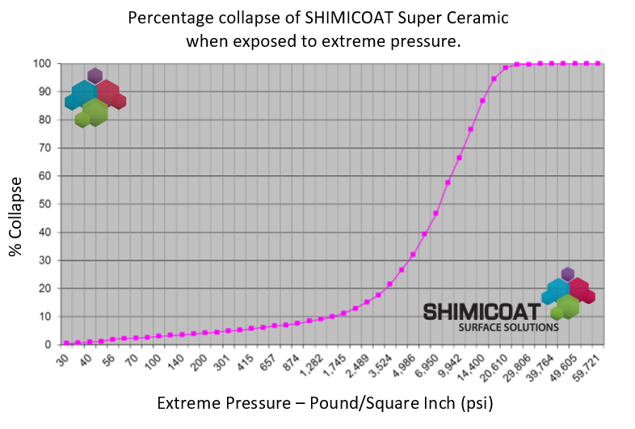

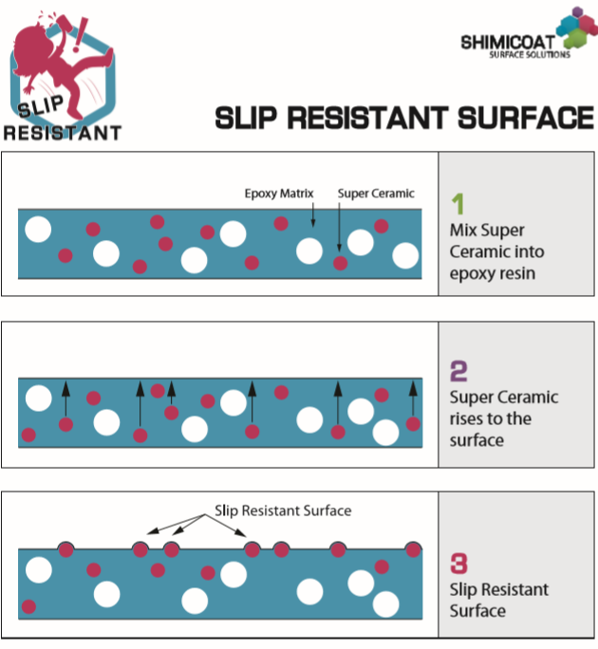

Viscosity vs Volume Filler Loading of SHIMICOAT Ceramic Filler Materials
SHIMICOAT Ceramic Filler offers lower viscosity at same volume loading. More filler at equal viscosity when compared to ordinary filler materials:

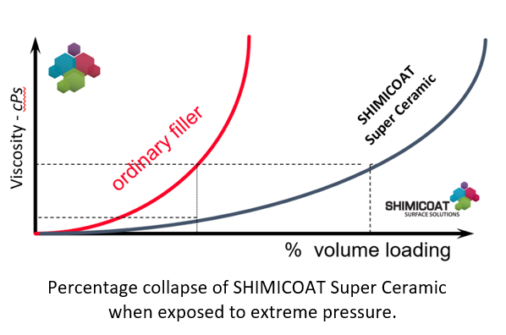

The product can be used as filler materials with any of SHIMICOAT Epoxy products (Clear or Tinted) to form an easy flow and easy apply epoxy mortar, ideally suitable for crack and hole repair prior to coating. Ceramic Filler Epoxy Mortar is non-sagging, engineered for high strength for both horizontal and vertical applications.

The product can also be added to epoxy and resin at the rate of 10% by volume to create slip resistant textured finish surface with P rating of P2 (Equivalent to R9):

For coarser and higher Slip rating surfaces, please view our SlipRes Xtra Grip.
Ceramic Filler can hold over 4,000 psi (33 MPa) pressure, equivalent to 1.5 Tone weight over each particle without any breakage. Mixing, processing and application cannot possible break advanced engineered structure of Ceramic Filler particles.

No | Grit Size | Oil-Wet Inclining Platform Test | Wet Pendulum Test
1 | Fine | R9 | P2
2 | Medium | R10 | P3
3 | Coarse | R11 | P4

Parameter | Value
Appearance | Free Flowing Light Powder
Colour | Off-White
Geometry | Engineered Spherical Shapes
Particle Size | 100-200 Micron
Bulk Density | 450g/Lt
Compression Strength | 4,800 PSI (33MPa)
Thermal Conductivity | <0.1 W/m/°C
Melting Point | 1,800°C

Direction
Ceramic Filler has three distinctive applications:
NO | Application | Usage | Direction
1 | Crack Repair | Twice as much as resin quantity (200% by volume) | Trawl and fill the crack.  Let it cure over-night (8-16 Hours depending on temperature)  Sand and Clear Up, to get the surface ready for Coating Application.
2 | Screeding | Same quantity as resin used  (100% by volume) | Screed over the entire floor.  Smooth off using trawl or squeegee.  Let it cure over night (8-16 Hours depending on temperature).
3 | SlipRes | 10% (by Volume) of  the quantity of resin used | Add to your resin.  Mix and apply using roller or squeegee.  Continuously mix to ensure ideal suspension, as SlipRes Ceramic Filler may float to the surface over time.  Let it cure over-night (8-16 Hours depending on temperature)
Ceramic Filler enhances the performance of Epoxy matrix by improving compression strength, density and specific gravity reduction, improved rheological characteristics, increased thermal and fire rating properties and ultimately, Slip Resistant attributes.
Ceramic Filler provides major functional benefits and added values through enhanced performance of surface coating beyond non-slip properties:
- Durability,
- Easy cleaning feature, Easy Mop, Easy Wipe.
- Enhanced Mechanical and chemical resistant properties,
- Fire resistant properties,

Mixing:
- Prepare Epoxy mix by adding appropriate quantity of Curing Agent (Part B) into the resin (part B).
- Mix thoroughly for 2-3 minutes manual or with mechanical mixer at low speed (750rmp Max).
- Add the correct quantity of Ceramic Filler materials (depending on your application) and mix for extra 1-2min to ensure complete suspension of particles into the epoxy matrix.
- Apply to the surface and use well within curing time.
Crack Repair: Twice as much as resin quantity (200% by volume)
Screeding: Same quantity as resin used (100% by volume)
SlipRes: 10% (by Volume) of the quantity of resin used.
For further information please contact our technical team at SHIMICOAT Pty Ltd.

WARNING
Keep out of reach of children
Read Safety Material Data Sheet (MSDS) of the product prior to use.

Storage
The products shall be stored out of direct sunlight and heat at all times. The shelf life of the product is over 24 months.

DISCLAIMER
Material Safety Data Sheet, Technical and Environmental Data Sheet can be provided upon request.
The information provided in this document is guidance only and considering the uses of this product are beyond the seller's control, the product is sold without guarantees or warranties. Warranties and guarantees shall be governed by SHIMICOAT Standard Terms of Sale. The purchaser shall make its own tests to determine the suitability for their specific application, and Shimicoat Pty Ltd is taking no responsibility for misuse of the product. The purchaser assumes all risk of use and handling of this product. This product will be happily replaced or credited back if defective. Beyond this, Shimicoat Pty Ltd is not liable for any damages caused by this product or its use.
This information and all further technical advice are based on our present knowledge and experience.
The customer is not released from the obligation to conduct careful inspection and testing of supplied goods.

Pack Sizes

Pack Sizes
1Kg | 2.5Lt
2Kg | 5Lt
4Kg | 10Lt
8Kg | 20Lt

